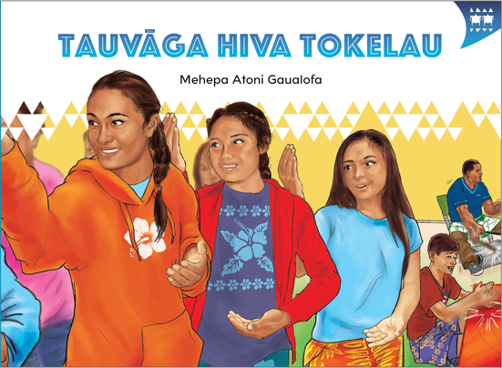
TEACHER SUPPORT MATERIALS TO ACCOMPANY:

Stories to Support the Pacific Learning Languages Series Resource
Muakiga! An Introduction to Gagana Tokelau

Tauvāga Hiva Tokelau
by Mehepa Atoni Gaualofa

Overview
These teacher support materials accompany the six storybooks developed especially to support the Learning Languages Series resource Muakiga! An Introduction to Gagana Tokelau. Each story gives students opportunities to extend their language and cultural knowledge and to practise reading the target language of specific units in Muakiga!
These teacher support materials suggest how teachers can use the six storybooks to foster gagana Tokelau learning at levels 1 and 2, particularly in the context of the Muakiga! programme.
The teaching-as-inquiry cycle and the Newton et al. research on intercultural communicative language teaching underpin these teacher support materials. See:
- the effective pedagogy section on page 35 of The New Zealand Curriculum
- the Newton et al.paper.

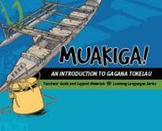
Muakiga! An Introduction to Gagana Tokelau
Muakiga! is a resource in the Learning Languages Series. It provides a language-teaching programme that can be used by teachers, including those who do not speak gagana Tokelau or know how to teach languages. Muakiga! includes:
- twenty units of three lessons each
- a range of language suitable for years 7–10 at levels 1 and 2 of the curriculum
- video and audio support to engage learners and demonstrate how fluent speakers
use the language
- lesson plans that could be linked to opportunities for learners to enjoy reading
gagana Tokelau texts.
You can find Muakiga! online here.

Engaging students with texts
The teacher’s role is to mediate the interactions between the student and the learning materials
and enable the student to meet their learning outcomes.

Tauvāga Hiva Tokelau
by Mehepa Atoni Gaualofa
This story supports Unit 18: Hiva ma nā Fakafiafiaga (Performing Arts) in Muakiga!

Learning goals
Encourage your students to set one or more of the following learning goals for their work with this storybook. The learning activities support these goals.
I will use gagana Tokelau to:
- read the story and understand it
- read the story aloud with clear pronunciation and reasonable fluency
- recognise and use some words and expressions in different contexts
- write texts with macrons and correct spelling
- talk or write about the story.
I will use English to:
- understand the story when it is read aloud
- talk about the content of the written and visual texts
- give examples of how Tokelau language and culture are organised in particular ways
- make connections with the language(s) and culture(s) I know
- research and present information about Tokelau culture and values in the story
- make connections with my learning in Unit 18 of Muakiga!

Language and Cultural Knowledge strands
The Language and Cultural Knowledge strands at levels 1 and 2 of Learning Languages in The New Zealand Curriculum require students to:
- recognise that the target language and culture are organised in particular ways
- make connections with known languages and cultures.
The language and cultural features of the written and visual texts in the storybook are described here.

(a) Language Knowledge
The language features of the written texts include:
- different verb forms, for example, takalo / play (singular) and tākakalo / play (plural); hāvavali / walk (plural); hau / come (singular) and ōmamai / come (plural) – note that ōmai is an alternative plural form for ōmamai
- use of uma with two different meanings, for example, kua uma te ākoga / after school (that is, when school is finished); i taimi uma / all the time; and i vāiaho uma / every week
- words transliterated or borrowed from English, for example, netipolo / netball; Ēheta / Easter; Niu Hila / New Zealand; Auhetalia / Australia; and hall (in Tokelau these buildings are referred to by their names)
- formulaic expressions, for example, E hē kō mautinoa. / I’m not sure.; Io lā, kua lelei. / OK.; E lelei. / Of course.; Hōvē. / Perhaps.; and Tēnā i kō. / Over there.
- time expressions, for example, i te afiafi na hohoko / the next evening; i te pō nei / tonight; and toe tolu ia vāiaho / in three weeks’ time
- dance instructions, for example, Fakavavevave te hihiva! / Go faster!; Matafiafia! / Smile!
- words with the same letter combinations, where macrons distinguish meaning, for example, matua / older; mātua / mother, mum; and matuā / extremely
- vocabulary associated with music and dancing, for example, tā te apa / strike the tin; pō te pōkihi / beat the drum; and Hōhō ki mua! / Move forwards!
- different forms of pronouns to give precise meaning, for example, ki māua / us (dual); koe / you (singular); koutou / you (plural); and tātou / us (inclusive – all of you and I).

(b) Cultural Knowledge
The cultural features of the written and visual texts include:
- the movement of people between Tokelau and New Zealand. Many settle in New Zealand permanently and organise events where Tokelau people can meet and share their own culture. The Tokelau Easter Tournament is an example of this. This tournament takes place every two years in some part of New Zealand. Groups come from other countries to participate in the competitions, which include sporting competitions as well as musical and dance events.
- different words for Easter, because of different missionary influences. Ēheta is the Protestant term for Easter. Catholics use the terms Pāheka or Pāhekate, which are transliterations of the English word “Paschal” (Passover).
- information that extends students’ learning about dance group preparations. This includes the process of selecting the best dancers for the group to perform in the competition, and the prestige of being selected for the first row. It also includes references to the music provided by the apa (drums made from empty biscuit tins) and pōkihi (square bass drums). Tokelau dance lines are made up of age groups, for example, young single women dance in the same line, young married women in another line, and the older married women in yet another line. Where there are two lines of the same age group, a front line of the best dancers is necessary. See Muakiga! Unit 18, pages 409–410, for more information on Tokelau performing arts.
- ways of addressing parents, for example, Mami as an equivalent to “Mum” in English.

Communication strand
Students learn to apply their language and cultural knowledge in different contexts and situations to communicate effectively for a range of purposes. As they become more effective communicators, students develop the receptive skills of listening, reading, and viewing and the productive skills of speaking, writing, and presenting or performing. These are summarised on the Learning Languages Wallchart.

(a) The New Zealand Curriculum
The achievement objectives in learning languages, levels 1 and 2 are generic.
In selected linguistic and socio-cultural contexts students will:
- receive and produce information
- produce and respond to questions and requests
- show social awareness when interacting with others.

(b) Gagana Tokelau: The Tokelau Language Guidelines
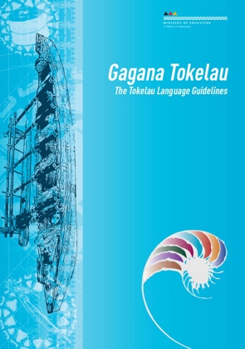
These guidelines offer achievement objectives that are more specific. You could use any of the following levels 1 and 2 achievement objectives to narrow the focus for your students to help them achieve particular competencies. In selected linguistic and socio-cultural contexts students will:
- make requests, give instructions, and respond to requests and
instructions (2.7)
- communicate interest, enjoyment, and need (2.3)
- use language, positioning, and movement to show respect (1.8).

(c) Muakiga! An Introduction to Gagana Tokelau
The Unit 18 learning outcomes for students are sharply focused. Students will:
- give and respond to instructions.

Cross-curricular links
Learners who are working at levels 1 and 2 in gagana Tokelau will be working at higher curriculum levels in other learning areas. Here are three examples of cross-curricular achievement objectives that could be linked to this story when you are planning links across curriculum learning areas.

The Arts, Level 3
Dance
Students will:
- explore and describe dances from a variety of cultures
- prepare and share dance movement individually and in pairs or groups.
Music
Students will:
- identify and describe the characteristics of music associated with a range of sound environments, in relation to historical, social, and cultural contexts.

Social Sciences, Level 3
Students will gain knowledge, skills, and experience to:
- understand how the movement of people affects cultural diversity and interaction in New Zealand.

Technology, Level 3 (Characteristics of Technology)
Students will:
- understand how society and environments impact on and are influenced by technology in historical and contemporary contexts and that technological knowledge is validated by successful function.

Values
The story illustrates the values of:
- community and participation for the common good
- respect for themselves and others.
See page 10 in The New Zealand Curriculum.
In addition, students will come to appreciate how the story reflects core Tokelau values of fakaaloalo (respect), māopoopo (inclusion), and vā feāloaki (relating to others). See pages 8–9 in Gagana Tokelau: The Tokelau Language Guidelines.

Effective pedagogy for language teaching
Effective pedagogy research is integrated into these teacher support materials.
The New Zealand Curriculum (pages 34–36) summarises evidence of the kinds of teaching approaches that consistently have an impact on student learning.
Research into second language acquisition pedagogy reviewed in Ellis (2005) establishes ten principles for teacher actions that promote student learning.
Research into intercultural communicative language teaching (Rivers, based on Newton et al. 2010) establishes six principles for a pedagogy that is effective in achieving the outcomes specified in The New Zealand Curriculum.

Language learning activities
Choose or adapt these learning activities to suit your students’ diverse needs and the particular objectives they are to achieve.
Link to prior learning
The students recall their prior learning of gagana Tokelau. They use this knowledge to help them read the story and understand it.
The students work in groups. They read the story and share with each other what they think the story is about. They use the words and expressions listed in the glossary to help them to make meaning from the written text. Each group presents their version of what the story is about to the class.
Project the English version, or hand out copies of it. The students read the gagana Tokelau text again, referencing the English version as they read, so that they can enjoy the story.
Dictation
The students write texts with appropriate use of macrons and correct spelling. They develop their understanding of how gagana Tokelau is organised in particular ways.
Dictation sharpens the students’ recognition of sound-spelling combinations and builds good spelling habits. Try these sentences. Note that they focus on the words matua, mātua, and matuā, which students need to distinguish in both spelling and meaning. Say each sentence twice. Give the students enough time to write each sentence in their books.
- Ke lea au ki toku mātua.
- E fanatu tō tuagane matua oi kave koe?
- E matuā lelei uma nā kauhiva ma e gali o lātou tēuga.
Project the sentences, or hand out copies of the storybooks for the students to find the sentences, so that they can correct their own work. Find out how well they managed the task. Ask them if this activity helped them to learn the spelling and associated meanings of these words. Tell them to write a note to themselves about what they need to do to improve their written accuracy.
Role-play reading
The students develop their pronunciation and reading fluency in gagana Tokelau. They develop their understanding of the story when it is read aloud.
The students work in groups. One student takes the role of narrator, or shares this role with others. To help the students become very familiar with the story as they read, give them copies of the English translation to refer to so that they can make meaning of what they are reading. You may wish to get a competent gagana Tokelau reader to help with the pronunciation.
Within their groups, the students read the story aloud, as a role-play. Ask group members to give feedback to the readers, congratulating them by saying Lelei or Mālō lava, or suggesting they try again to get the pronunciation right. This process helps them to develop their critical awareness of the pronunciation of gagana Tokelau.
Sequencing
The students recall their prior learning of gagana Tokelau and develop their understanding of how gagana Tokelau is organised in particular ways.
The students work in pairs or groups. Photocopy (or retype) sentences from page 11 onto card. Cut the card so that each piece has one sentence. Hand out the sets of sentences, one to each pair or group. The students arrange the sentences in sequence without referring to the storybook. They use the complete text to check their work. Or read the passage aloud so that the students can check their sequences. To encourage rapid reading, place a time limit on their task. Repeat this activity using other pages in the storybook.
Patterns of language – instructions
The students connect with their learning in Unit 18. They respond to instructions in a genuine situation and use language, positioning, and movement when performing. The activity also enables them to explore and describe dances from another culture, and to prepare and share dance movements individually and in pairs or groups.
Arrange for community members to come to your class and teach students a hiva (dance). Discuss with them the kinds of language that students have learned in Unit 18. Then have the hiva teacher use these instructions (and other instructions the person considers important) to teach the students the movements and positioning for the hiva.
If you do not have people to play music for the hiva, use a song from the print and CD resource Fātuga Faka-Tokelau: Tokelauan Songs [item 31047].
Presenting information
The students explore and reflect on how language and culture are organised in particular ways when they research and present information on aspects of Tokelau culture and values included in the story. They also make connections with the language(s) and culture(s) they know.
The students work in pairs, or groups, and then present their information on posters to the rest of the class. They make their presentations orally, supported by posters that have a combination of written and visual texts for them to refer to as they speak.
Possible themes:
- a list of formulaic expressions used in conversations in the story, prepared as a poster for the classroom wall for others to refer to and use in appropriate contexts
- types of hiva, with brief descriptions of them
- instruments used to accompany hiva, and their technologies
- costumes people wear for hiva, and the technologies used to make them
- Easter Tournament activities and events
- particular colours or symbols in Tokelau culture, and where these are used, for example in costumes
- the significance of hiva, and the values associated with them.
The students use a range of sources from which to gather their information, including the Internet, reference books, and Tokelau community members. Tokelau people would be able to discuss the significance of hiva and the values associated with them. Your students can make comparisons and connections with associated practices in their own culture(s).
Viewing and presenting – spoken communication
The students process vocabulary and language structures, develop fluency in speaking, and adapt language to suit their own communicative purposes.
Make photocopied sets of the illustrations from the storybook (minus the written text), enough for one set per group. The students work in groups. They prepare a retelling of the story (narrative and/or conversation) using the illustrations to guide their presentations. They may need to prepare written scripts to support their presentations.
Give them time to rehearse their presentations, to enable them to become more fluent when speaking.
Challenge your students to retell the story without using any notes. Students who are more confident in their use of gagana Tokelau may be able to respond to this challenge.
Telling the story – spoken communication
The students produce information by telling the story to others.
The students give a short, spoken presentation (to their group or class) based on the storybook content, as an individual task. They retell the story in about ten sentences. They tell the story from the point of view of Te Hei or Lehi.
The students prepare their talk and then practise it until they are reasonably fluent. They may use notes as a prompt.
Record these talks. Play the recording so that students can self-monitor their performances as well as receive others’ feedback about the improvements they need to make. This feedback may include comment on how well:
- they can be heard (audibility)
- they can be understood (pronunciation, stress)
- the story makes sense (logical sequence of actions)
- the story is presented (fluency, lack of hesitation, not looking at notes).
Technologies for the performing arts in agānuku Tokelau
The students develop their understanding of how society and environments impact on and are influenced by technology in historical and contemporary contexts. They make connections with other language(s) and culture(s) that they are familiar with.
The story shows aspects of preparations and performances at a Tokelau Easter Tournament in New Zealand. Facilitate a discussion with your students, or set research questions, about the different facilities and technologies used in the performing arts in New Zealand and Tokelau settings. The students explore how the use of locally-available materials influence the development of costumes and the choice of musical instruments.
Reflecting on their learning
Help the students to reflect on their learning, and also on how they learn. Students could share these reflections with another student, a small group of students, or the whole class. As a prompt, ask the students questions such as:
- What strategies helped you to understand the story?
- What strategies helped you to remember the new language?
- How can you use the new language in other contexts?
- Can you identify aspects of new learning about agānuku Tokelau?
- How have you improved your use of gagana Tokelau?
For example, a student might say:
“I can now tell the story of Te Hei, who learned to dance the Tokelau way. Retelling the story helped me to remember new language. I learned a hiva and managed to follow the instructions in gagana Tokelau.”

English version of the story
In English, this story by Mehepa Atoni Gaualofa is:

Tokelau Dance Competition
page 2
Te Hei and her friends, Justine and Hana, were playing netball after school. Te Hei enjoys playing netball. It’s her favourite sport. She plays well. Her movements are graceful. She smiles a lot.
Her friends play well, too. They are all in the school netball team.
page 3
They walked home together. On their way, Justine said to Te Hei, “Hana and I are going to join
the Tokelau dancing group. There is a practice tomorrow night in the church hall. Do you want to
come with us?”
“What are you practising for?” asked Te Hei.
“It’s for the Youth Gathering at the Easter Tournament. It’s going to be here in our region this year. And lots of people will come from all over New Zealand. It’s awesome.”
“I’m not sure,” said Te Hei. “I don’t know how to dance the Tokelau way. I prefer playing netball.”
“But we love the dancing. It’s such fun. Please come with us,” her friends said.
“OK,” said Te Hei. “I’ll ask my mother.”
page 4
“Hi, Mum,” said Te Hei. She went into the kitchen, where her mother was preparing dinner.
“Hi, Te Hei,” answered her mother, as she put the chicken into the oven. “Did you have a good
day at school?”
page 5
“Yes, thanks, Mum,” said Te Hei. “We had netball practice. That was fun.” Te Hei helped her
mother prepare the vegetables. She cut up the onions and potatoes. “My friends asked me to go with
them to the Tokelau dance practice tomorrow night. It’s at the church hall. Can I go, please?”
Te Hei asked her mum.
Her mum smiled. “Of course,” she said. “Your older brother can take you.”
The next evening, Te Hei and her brother, Lehi, walked to the church hall. It wasn’t far from their house. “It’s awesome that you’re coming tonight to learn how to dance the Tokelau way,” Lehi said
to Te Hei.
The above page:
Text copyright © Crown
“But I don’t know how to dance the Tokelau way,” Te Hei said to her brother. “I’m worried.
It looks difficult.”
“I’m learning how to play the apa and the pōkihi. It’s fun! You just need to practise,” said her brother.
“Maybe,” said Te Hei. She wasn’t so sure.
page 6
Wow! The hall was full of people. She saw the men with their apa and pōkihi. They were getting ready to play. She saw the older women and men, and lots of young people, getting ready to dance. She saw more people arriving. She looked for her friends. “Where are my friends, Justine and Hana?” she asked her brother.
He smiled. “Look! Over there,” he said. “They’re waving to you.”
Te Hei went over to join her friends.
page 7
“Hi, Te Hei,” said her friends.
“It’s good to see you here,” said Justine.
“Yeah!” agreed Hana.
“Hi, Justine and Hana,” replied Te Hei. “I came with my brother, Lehi. He’s over there. He’s learning to play the apa and pōkihi.”
“Awesome!” said Justine. “Come with us.”
They walked over to the dance group. There were four rows. There was room for them in the row right at the back.
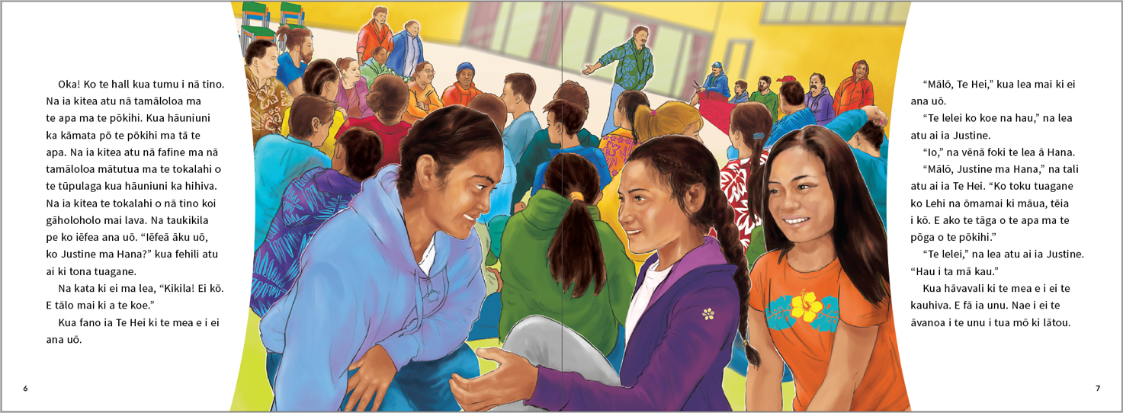
page 8
“Welcome, everyone. Thank you for coming,” said the dance teacher. “Now let’s start to dance.
Are you ready?”
The men started playing the apa and pōkihi. The dancers started to dance.
“Go slow!” said the dance teacher. “Move forwards! Move back!” said the dance teacher.
“Now down! Now up!”
“Like this, Te Hei,” whispered Justine.
“Watch me, Te Hei,” said Hana. “You’ve got it!”
“That’s right, Te Hei,” said the dance teacher. “You’re learning fast.” The dance teacher thanked everyone for coming. “Please come to every practice,” he said. “In three weeks’ time, we’ll pick
the rows.”
The above page:
Text and illustration copyright © Crown

page 9
Te Hei and her brother, Lehi, went to the church hall every week. Lehi practised his playing.
Te Hei practised her dancing.
“Smile!” said the dance teacher. “Go fast!” he said. “Now go faster!” Te Hei and her friends went fast. Then they went faster. They smiled.
“That’s right, everyone,” said the dance teacher. “Please practise the dancing at home. Next week, I’ll pick the rows.”
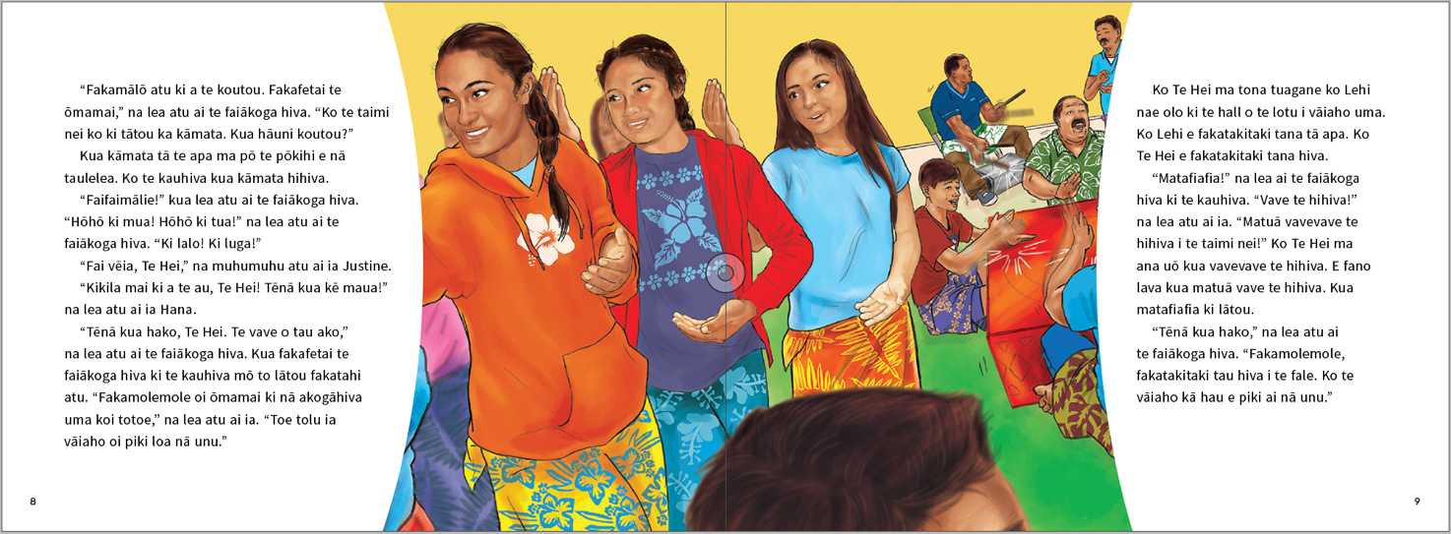
page 10
Every day, Te Hei practised her dancing. Lehi practised his playing. Then it was the day before
the next practice at the church hall.
“Watch me, Mum,” said Te Hei. She moved backwards. Then she moved forwards. She went down. Then she went up. She turned right. Then she turned left. She went slowly. She went faster. Then she went really fast!
Her mum clapped. “It’s beautiful, Te Hei,” she said.
page 11
Te Hei and her brother walked to the church hall. Te Hei was excited. Tonight, the dance teacher was picking the dancers for the rows.
“Are you ready? Please dance, then we will call your names for the rows,” said the dance teacher.
Te Hei danced and smiled and her movements were graceful.
Then the dance teacher started to call the names for the rows. He called the names for the last row. He called the names for the third row. He called the names for the second row. Te Hei was waiting
for her name to be called. Then the dance teacher started to call the names for the first row.
Suddenly he called her name. Te Hei couldn’t believe that she was in the front row!
The above page:
Text and illustration copyright © Crown
page 12
At the Easter Tournament on Saturday night, Te Hei’s dance group waited for their turn.
A dance group from Hawaiʻi performed. A dance group from Tokelau performed. A dance group
from Australia performed. They were all excellent dancers and their costumes were beautiful.
Now it was the turn of their dance group to perform. Te Hei danced and smiled and her
movements were graceful.
But the group from Hawaiʻi won the competition.
Te Hei was disappointed. “At the next Easter Tournament, our group is going to win!”
Te Hei told her friends.

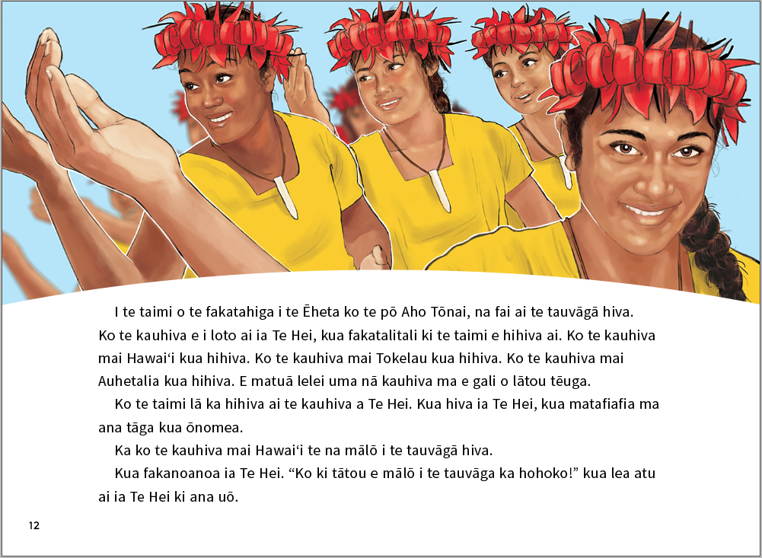

ISBN 978-1-77669-706-9 (WORD)
ISBN 978-1-77669-707-6 (PDF)
The above page:
Text and illustration copyright © Crown

Newton, J., Yates, E., Shearn, S., and Nowitzki, W. (2009). Intercultural Communicative Language Teaching: Implications for Effective Teaching and Learning. Wellington: Ministry of Education.

